MANAGEMENT INFORMATION SYSTEM

LAB EXPERIMENTS

Jashwini A-192124192

7) Draw a UML diagram for online purchasing system**.** Provide top level use cases for a  web customer making purchases online. Web customer actor uses some web site to  make purchases online. Top level use cases are View Items**,** Make Purchase and Client  Register.

**Aim:**

To develop a **Use Case Diagram** for an **Online Purchasing System**, illustrating the top-level interactions between web customers and the system.

**Procedure:**

1. **Identify Key Actors:**
   * **Web Customer**: Uses the website to browse items and make purchases.
   * **Online Purchasing System**: Manages the shopping process, including viewing items, handling purchases, and customer registration.
2. **Define the Top-Level Use Cases:**
   * **View Items**: Allows the web customer to browse available products.
   * **Make Purchase**: The customer selects items, adds them to the cart, provides payment details, and confirms the order.
   * **Client Register**: Enables new customers to create an account and register their details.
3. **Establish Relationships:**
   * The **Web Customer** interacts with the **Online Purchasing System** to view items.
   * The **Web Customer** registers before making a purchase.
   * The **Online Purchasing System** processes the purchase and payment.

**Output:**

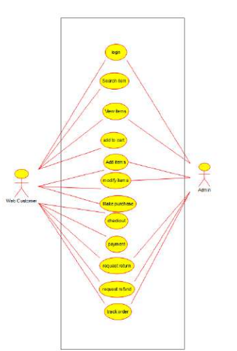

**Use case diagram**

**Result:**

A **UML Use Case Diagram** will be created based on the above analysis.